Ranoa, Julius

CSC 121 001 Computer Science

22 September 2017 Friday

Part I. Review Questions and Exercises.

Chapter 6 Functions.

Qn. 1, 2, 3, 5, 7, 9, 10, 13, 14, 15, 20, 21, 23.

1. The function header is a part of function definition that shows the function name, return type, and parameter list.
2. If a function doesn’t return a value, the word void will appear as its return type.
3. If a function showValue has the following header: void showValue(int quantity) you would use the statement showValue(5) to call it with argument 5.
4. Values that are sent into a function are called arguments.
5. When only a copy of an argument is passed to a function, it is said to be passed by value.
6. A(n) function prototype eliminates the need to place a function definition before all calls to the function.
7. Global variables are defined outside all functions and are accessible to any function within their scope.
8. If a function has a local variable with the same name as a global variable, only local variable can be seen by the function.
9. Static local variables retain their value between function calls.
10. The return statement causes a function to end immediately.
11. Reference variables are defined like regular variables, except there is   
    a(n) & (ampersand) in front of the name.
12. Reference variables allow arguments to be passed by reference.
13. Two or more functions may have the same name, as long as their parameter lists are different.

Part II. Programming Challenge.

Page 399. Qn.16 Overloaded Hospital

Requirements:

1. Ask user if patient is either “inpatient” or “outpatient”.
2. If patient is “inpatient”, ask the user for the following information: (1) length of stay in days, (2) daily rate, (3) hospital service charges, (4) medication costs.
3. If patient is “outpatient”, only ask for the following information: (3) hospital service charges, and (4) medication costs.
4. Validate that each input from point 2 and 3 is not less than zero. If it is, user input should be re-entered.
5. Use two overloaded functions to calculate the total charges, one for “inpatient” and the other for “outpatient”. Return the total charge.

Screenshot of Runtime.

Figure 1. With INPATIENT data Figure 2. With OUTPATIENT data

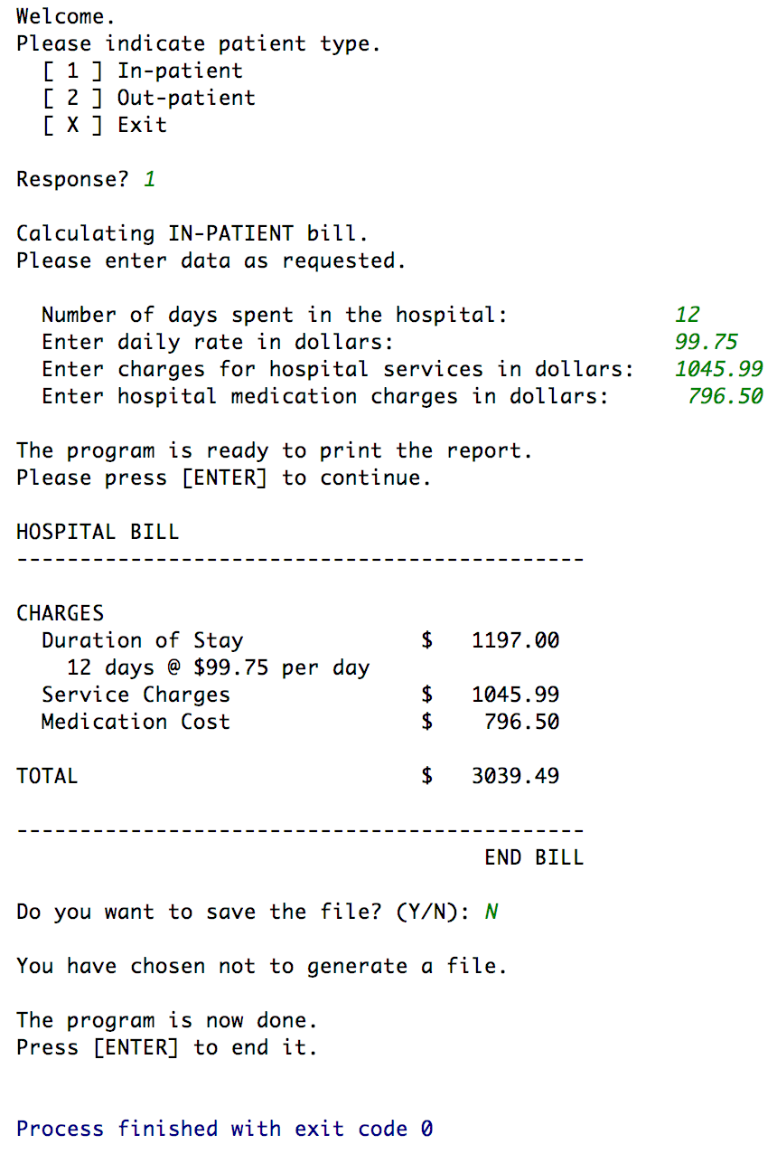 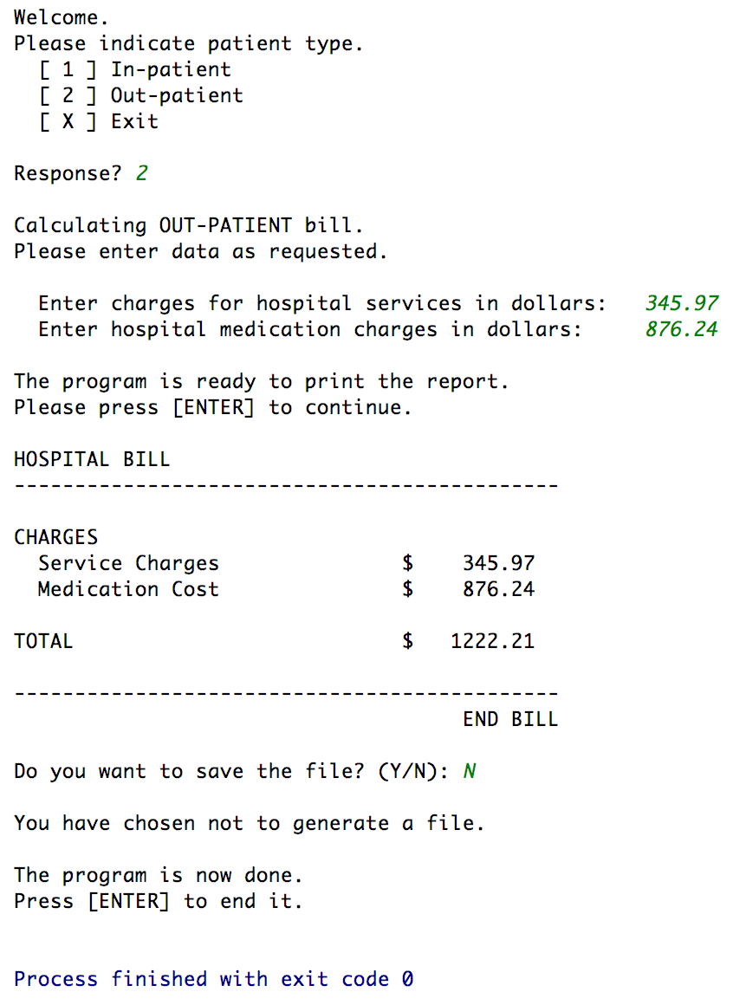



Project Files.

1. main.cpp
2. HospitalBill.h
3. HospitalBill.cpp

Source code is included on Pages 3 – 10.

For the actual files, visit the following link:

<https://github.com/TheLoneWoof1102/FA17_CSC121001/tree/master/Source%20Code/Homework-Ch6.Qn16>

It’s a link to a folder in a public repository in GitHub that contains all my work for this class.

**main.cpp**



**HospitalBill.h**



**HospitalBill.cpp**



**HospitalBill.cpp – cont’d.**

**HospitalBill.cpp – cont’d.**



**HospitalBill.cpp – cont’d.******

**HospitalBill.cpp – cont’d**



**HospitalBill.cpp – cont’d.**



**HospitalBill.cpp – cont’d.**



**// End of *HospitalBill.cpp***